**Eastern Mediterranean University**



**Department of Computer Engineering**

**Famagusta, North Cyprus**

**Project Report CMSE 326**

**Analysis, Comparison, Discussion and Testing of various websites**

**Project 1**

**Students: Group 8**

1. Talal Hatem Mahdy (147139)
2. Ahmet Sezen (142323)
3. Mert Kasar (120938)

**Instructor:** Assoc. Prof. Dr. Alexander Chefranov  
**Lab Coordinator:** Kamran Kamaei

**April 2016**

**Outline:**

The aim of this project is to analyze, compare, discuss and test three websites, namely, **abet.org, emu.edu.tr, and ncc.metu.edu.tr** against various quality and website testing measures. These tests are to be performed with the help of various online website testing tools. The tests to be performed are as follows:

1. Security and Safety   
2. Correctness of the links  
3. Search functionality  
4. Flow testing and easiness of navigation  
5. Markup validation test (CSS and HTML)  
6. Performance, stress, speed and load tests  
7. SEO Analysis  
8. UI tests:  
 8.1. Responsive test  
 8.2. Cross Browser testing

**Group members and duties distribution:**

Talal: Conducts the tests for **emu.edu.tr** website.  
Ahmet: Conducts the tests for **abet.org** website.  
Mert: Conducts the tests for **ncc.metu.edu.tr** website.

**Project Planning:**

1st Week: Meet each other; Distribute the responsibilities of each member; Conduct  
 the tests for **emu.edu.tr** website.

2nd Week: Conduct the tests for **abet.org** website and discuss the test results for  
 **emu.edu.tr** website; Prepare initial report and presentation.

3rd Week: Conduct the tests for **ncc.metu.edu.tr** website and discuss the test  
 results for **abet.org** website; Update the report and presentation.

4th Week: Discuss the test results for **ncc.metu.edu.tr** website; Prepare the final  
 report, presentation and CD.

**Test 1: Security and Safety**

Aim:   
The aim of this test is to certify that a website is safe to visit. The website is tested for any known malware or security vulnerabilities that may affect the visitor of the website.  
  
Testing Approach:  
This test is to be conducted using two different online tools which verify the security and safety of the website. These websites are http://scanurl.net/ and https://safeweb.norton.com/.   
  
Test Results:   
By comparing the three websites using the Norton website, we find that there are no differences among the three websites as all of them seem to be safe. But looking at the scanurl website, we find that there are some minor differences in the Web of Trust (WOT) rating. ABET website achieved a 92/100 in the trustworthiness test and 94/100 in the child safety test. METU website achieved a 74/100 in the trustworthiness test and 96/100 in the child safety test. EMU website achieved a 64/100 in the trustworthiness test and 84/100 in the child safety test. Therefore, we can say that the ABET website ranked number 1 in this test followed by METU and EMU websites.  
  
Conclusion and Recommendations:   
Looking at the test results, it is obvious that these websites are safe and secure and won’t attempt to compromise the privacy of the user. But the WOT ratings proved that although the websites are safe, there may be some differences in terms of child safety and trustworthiness issues. One recommendation would be to implement an https connection to further increase the security of the websites.

**Test 2: Correctness of the links**

Aim:   
This test checks whether all the links in the website are valid or not.

Testing Approach:  
The test is to be done using one of the World Wide Web Consortium (W3C) website testing online tools which is the https://validator.w3.org/checklink website. We will also conduct the test using another tool which is the http://smallseotools.com/websites-broken-link-checker/ website.

Test Results:  
Looking at the results given by the W3C tool, we find that the ABET website achieved the best results. The results are given in terms of the list of broken links, redirects and anchors. EMU website had 4 broken links, 5 redirects and 43 anchors. METU website had 2 broken links, 3 redirects, 6 anchors and 4 links that can only be accessed if the browser has JavaScript support. ABET website had 2 broken links, 1 redirect and 48 anchors. The results given by the smallseo tool were almost the same as its W3C counterpart. But note that the smallseo tool only checks for broken links and does not check for redirects and anchors.

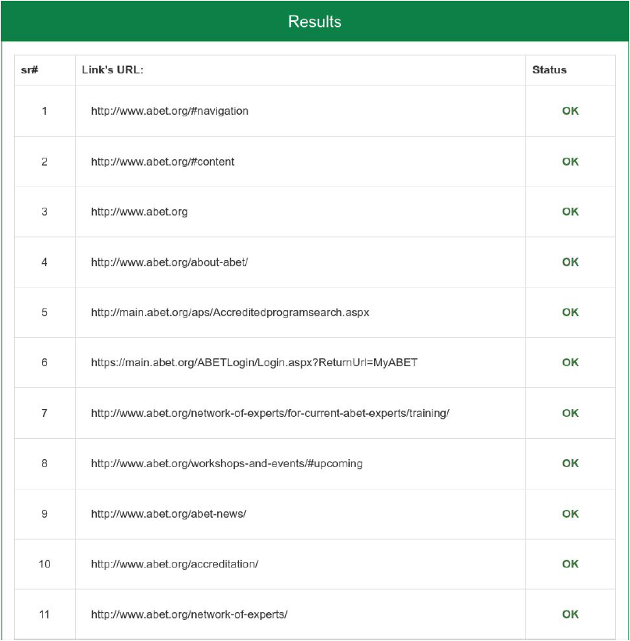

Conclusion and Recommendation:  
ABET website achieved the number one website in this test also, followed by EMU and METU. The ABET website has a total of 48 anchor links which makes it easy to navigate the website. All websites had a very few broken links and redirects which is a good thing. I recommend that the METU website include more anchor links in their website to improve the navigation experience.

**Test 3: Search functionality**

Aim:   
The aim of this test is to test the search feature which allows us to search for any item which is available in the website.

Testing Approach:  
There are many ways to test the search functionality of a website but we are going to test it using some important test cases.  
a. Can we search in specific categories of the website? E.g. Search in academics  
 section only (EMU & METU Websites), search in accreditation section only  
 (ABET website), etc.  
b. Will the search results be based on the complete string or based on each word of  
 the string? E.g. Does searching for the word “Eastern” on ABET website give us  
 a result regarding Eastern Mediterranean University?  
c. Is there an Autosuggest feature in the search field as on google.com?  
d. Is it allowed to press Enter key instead of clicking on the search button?  
e. If the user does a spelling mistake, will closely matched results be displayed or  
 not?  
f. What happens if the search string doesn’t match any items?  
g. What happens if we only enter numbers?   
h. What happens if we flip the words to be searched? E.g. Searching “Calendar  
 Academic” instead of “Academic Calendar”.   
i. What happens if the string contains more than one space between each word?  
 E.g. “Academic Calendar”.

Test Results:  
a. EMU website allows us to search for contents in the whole site and it allows us  
 to search for staff and alumni. METU and ABET websites search functions only  
 search the whole website. But ABET website has a separate search functionality  
 to search for Accredited Programs and Schools.   
b. Searching for the word “Academic” on EMU and METU websites successfully  
 yields results for Academic Calendar, Academic Rules, Academic Staff, etc.  
 However, searching for the word “Eastern” on ABET website does not give  
 results for Eastern Mediterranean University.   
c. The Autosuggest feature is not available in any of the websites.  
d. Pressing Enter instead of clicking Search works on all websites.  
e. Searching for the term “Acdmic Calendar” METU website gives results for  
 Academic Calendar. But entering the same string for EMU website does not  
 any result. Searching for the string “Devlped by technical professionals” on  
 ABET website instead of “Developed by technical professionals” does not give  
 expected results even though this is a string in the About ABET section of the  
 website and even though it’s a slight spelling mistake.   
f. Since METU website’s search function is powered by Google, it’ll almost  
 always give a search result regardless of what we enter. This is not the case for  
 EMU and ABET websites.  
g. Searching for “20000” on EMU website (number of students in EMU) gives  
 results regarding the Why EMU page on the website. Searching for “23000” on  
 METU website gives similar results. Searching for “+1.410.347.7729” which is  
 the media inquiries number for ABET gives the expected results which is the  
 About ABET page on the website.   
h. Searching for “University Eastern Mediterranean” instead of “Eastern  
 Mediterranean University” in the School search function of ABET website does  
 not give any result. Similar results were noticed for EMU website when  
 searching for the string “Calendar Academic” instead of “Academic Calendar”.  
 METU website however does not have any problems if we change the order of  
 string.   
i. The results of part (h) are similar as the results of this part of the test.

Conclusion and Recommendations:  
It is clear that the search function on all three websites works in general but is far from perfect. The search function for METU website was the most effective out of the three websites since it is powered by Google. This is followed by EMU and ABET websites. The bad thing about ABET’s search function is that there is no universal website search. This means that we have to visit a separate section of the website to search for accredited programs and schools. I recommend that the three websites work on improving one of the most important sections of a website which is search functionality since it makes it a lot easier for the visitor of the website.

**Test 4: Flow Testing and easiness of navigation**

Aim:   
The aim of this test is to check whether it is easy for the visitor of the website to navigate and flow through the website.

Testing Approach:  
To conduct this test, we have to answer these questions:  
How easy/difficult is it to get from Point A to point B on the website?  
How easy/difficult is it to find a specific piece of information on the website?

To conduct this test, we will consider two test cases for each website. For EMU website, first case is that we are willing to check the computer engineering program curriculum from the home page of EMU website. Second case is that we are willing to check the Academic Calendar from the page we are currently on (CE Curriculum). We will conduct a similar test for the METU website. For the ABET website, will consider that we are on the homepage and we are willing to check the ABET accredited programs for EMU. Then from that point, we are willing to subscribe to ABET emails newsletters.

Test Results:   
For the EMU test, the first flow case goes like this:  
Home > Academics (drop down list) > Engineering > Computer Engineering (B.S.) > Curriculum  
and the second flow case goes like this:  
Curriculum > Students > Academic Calendar > General Academic Calendar  
  
For the METU test, the first flow case goes like this:  
Home > Undergraduate Programs > Computer Engineering (forwarded to a separate website for CMPE) > Undergraduate Programs > Curriculum  
and the second flow case goes like this:  
Close the newly opened page > Academic > Academic Calendar  
  
  
  
  
For the ABET test, the first flow case goes like this:  
Home > find an abet-accredited program > school name search > Search results page > EMU accredited programs page  
and the second flow case goes like this:  
EMU accredited programs page > ABET news > sign up for our newsletter  
  
Conclusion and Recommendations:  
As we can see from the above test results, the navigation and flow is usually very easy for all the three websites. But for the METU website, it was a bit more difficult since we are being forwarded to many different websites whenever we want to check something. I would like to appraise all websites for implementing many drop-down lists which makes it a lot easier to navigate and classify the websites. I recommend that the METU website combine the information from all the different websites into the main website to make it easier for the visitor.

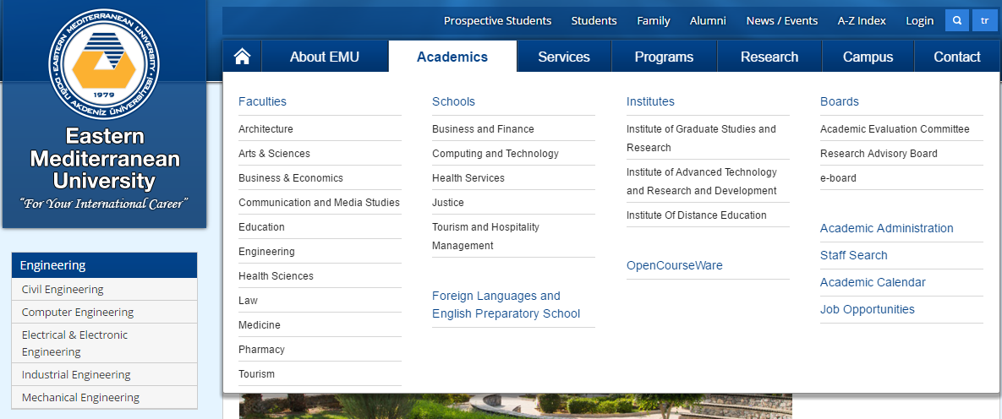

**Test 5: Markup Validation Test (CSS and HTML)**

Aim:   
The aim of this test is to validate whether the HTML (Hypertext Markup Language) and CSS (Cascading Style Sheets) codes of the websites are well formed or not. This is done to check to check whether a page is built in accordance with Web standards.

Testing Approach:  
To conduct this test, we are going to use four separate online tools. These tools are W3C’s Markup Validation Service https://validator.w3.org/nu,  
W3C’s CSS Validation Service http://jigsaw.w3.org/css-validator, http://www.htmlportal.net/html-validator/ website, and   
http://www.cssportal.com/css-validator/ website.

Test Results:  
For EMU website:  
W3C HTML tool: 27 Errors, 23 Warnings  
W3C CSS tool: 808 Errors, 830 Warnings  
htmlportal tool: 27 Errors, 23 Warnings  
cssportal tool: 808 Errors, 830 Warnings  
  
For ABET website:  
W3C HTML tool: 1 Warning  
W3C CSS tool: 20 Errors, 95 Warnings  
htmlportal tool: 1 Warning  
cssportal tool: 20 Errors, 95 Warnings  
  
For METU website:  
W3C HTML tool: 195 Errors, 47 Warnings  
W3C CSS tool: 4 Errors, 8 Warnings  
htmlportal tool: 195 Errors, 47 Warnings  
cssportal tool: 4 Errors, 8 Warning

Conclusion and Recommendations:   
Looking at the test results, it is obvious that the ABET website is the best website in regards to HTML and CSS web code as it contains the least number of errors. We can notice that the EMU website contains many CSS errors while the METU website contains many HTML errors. If there are many HTML and CSS errors, a website may not display correctly on some browsers. But many modern browsers can tolerate these errors and still display the content. Note that some browsers will not display some content as expected even though no errors are available, while other browsers can successfully display it. I recommend that EMU and METU website work on fixing these important errors as soon as possible to avoid any further issues in the future.

**Test 6: Performance, stress, speed and load tests**

Aim:   
The aim of this test is to determine whether a website has a high or low performance and speed both while loading and while under stress. Load testing is the process of putting demand on a website and measuring its response under both normal and anticipated peak load conditions. When the load placed on a website (many visitors at the same time) rises above normal usage to test the website at unusually high or peak loads, it is known as stress testing. Usually, when a website is under stress, it’s loading speed decreases.

Testing Approach:   
To conduct this test, we are going to use 2 separate online tools. These tools are http://www.webpagetest.org/ website and Google’s PageSpeed Insights tool https://developers.google.com/speed/pagespeed/insights/.  
Webpagetest tool tests the load time based on a first view of a webpage (website is opened for the first time) and repeated view of a webpage from a server and a connection speed of our choice. We chose the server to be located in Frankfurt, Germany and the connection speed to be 5/1 mbps. Google’s PageSpeed Insights tool gives test results for both the mobile and desktop platforms. It gives an overall score (out of 100) for the website’s load time based on some factors including server response time, image load time, plugins used, whether the HTML, CSS and JavaScript code is minified, etc. It also gives an overall score based on how user friendly is it on the mobile platform.

Test Results:  
For EMU Website:  
webpagetest: first view load time = 9.698s  
 repeated view load time = 4.599s  
PageSpeed Insights: mobile score = 74/100  
 user experience score = 99/100  
 desktop score = 69/100  
  
For ABET Website:  
webpagetest: first view load time = 5.737s  
 repeated view load time = 4.821s  
PageSpeed Insights: mobile score = 71/100  
 user experience score = 98/100  
 desktop score = 84/100  
  
For METU Website:  
webpagetest: first view load time = 4.359s  
 repeated view load time = 2.363s  
PageSpeed Insights: mobile score = 84/100  
 user experience score = 100/100  
 desktop score = 69/100

Conclusion and Recommendations:   
As we can see from the above results, METU website has the lowest load times among the three websites. It also has the best mobile and user experience scores according to Google’s PageSpeed Insights tool. But it does not have the best desktop score as that goes to the ABET website. We can say that the websites have excellent load times and are able to perform well under stress. But the performance can be further improved by some steps. Compacting the HTML, CSS, JS codes can save many bytes of data and speed up download and parse times. Properly formatting and compressing images can save many bytes of data. The servers of the websites should not take more than 200ms to respond and they should be monitored and inspected for any future performance regressions

**Test 7: SEO Analysis**

Aim:   
Search Engine Optimization (SEO) is the process of affecting the visibility of a website in a search engine’s results. The higher the page is ranked on a search engine’s results, the more visitors it will receive. The aim of this test is to try to rank the websites according to how good/bad are they Search Engine Optimized and check which site performs better on search engines like Google, Yahoo and Bing.

Testing Approach:   
To conduct this test, we are going to use two separate online tools. These tools are http://seositecheckup.com/ website and   
http://app.upcity.com/free-tools/seo-report-card/ website. These websites generate reports about the SEO of websites and gives us useful information on why the website achieved this rank. The Upcity website uses many factors such as Rank Analysis, Link Building, Website Accessibility, Trust Metrics, etc. and gives the websites a rank out of 100 for their SEO performance. The seositecheckup website uses many more factors such as Google Analytics Test, HTML page size test, Meta tags analyzer to rank the websites out of 100 for their SEO performance.

Test Results:   
For EMU website:  
seositescheckup: 70/100  
Upcity: 67/100  
For ABET website:  
seositescheckup: 65/100  
Upcity: 100/100  
For METU website:  
seositescheckup: 62/100  
Upcity: 56/100

Conclusion and Recommendations:  
It is difficult to say who’s the best website in this test category since all of them perform well in SEO. But we can say that METU website had the lowest rank since it is a somewhat new website and is still catching up on search engines like Google and Yahoo. I have no recommendation to the websites other than to continue this approach of optimizing their websites using various SEO techniques.

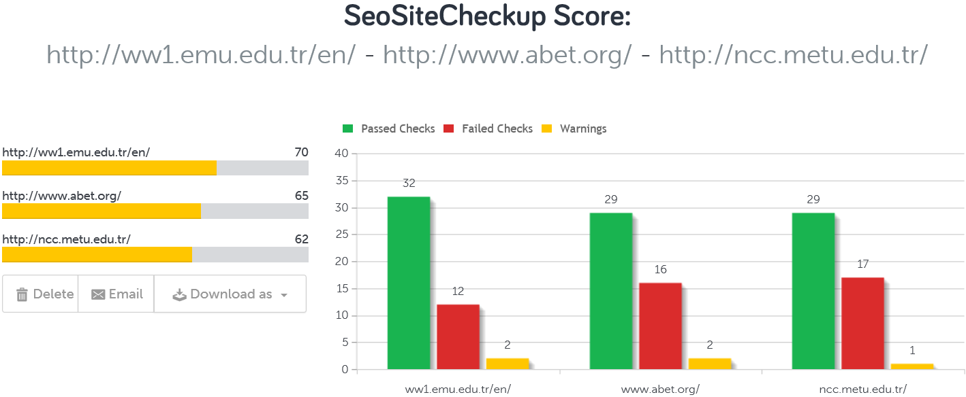

**Test 8: Responsive test**

Aim:  
This test aims to verify whether the website follows the Responsive Web Design (RWD) guidelines. RWD is an approach to web design aimed at designing websites to provide an optimal viewing and interaction experience, easy reading and navigation with a minimum of resizing, panning and scrolling across a wide range of devices like laptops, smartphones, tablets, etc.

Testing Approach:  
There are many online tools that help us verify whether a website is responsive. We are going to use 2 tools which are http://nibbler.silktide.com/ website and http://mattkersley.com/responsive/ website. These tools allow us to view the required websites from a smartphone/tablet perspective and to verify if the website is designed to be used on a smartphone/tablet. The nibbler website claims that there are three types of mobile optimizations when a user visits a website from his phone/tablet. A website may redirect the user to a separate mobile website when the server detects that the user is using a mobile device. A website may also return mobile optimized HTML and send back different content which is optimized for mobile devices. But the best approach according to Nibbler is when a website uses CSS Media Queries to adapt the look of the website upon screen size. Based on these criteria, Nibbler ranks websites from a score of 10. The mattkersley website allows to directly view and interact with the websites from a phone/tablet perspective using a simulated phone/tablet which appears on the screen and allows us to test for ourselves whether a website is responsive or not.

Test Results:  
For EMU and ABET Websites:  
mattkersley: The websites appears well optimized for mobile devices and lower  
 screen resolutions.  
Nibbler: Both websites received a 10/10 score for mobile optimization. Both  
 websites use CSS media queries to adapt the look of the website based  
 upon screen size.  
For METU website:  
mattkersley: The websites appears well optimized for mobile devices and lower  
 screen resolutions.  
Nibbler: The website received a 5.8/10 score for mobile optimization. The website  
 redirects users to a separate website http://ncc.metu.edu.tr/mobil/ when  
 viewed from a mobile device and does not implement CSS media queries.

Conclusion and Recommendations:  
All websites perform very well in this test category. But METU website uses a less efficient approach to optimize the website for mobile devices. I recommend that they use CSS media queries to adapt the look of the website based upon screen size.

Test 9: Cross Browser Testing

Aim:  
Nowadays, there are many browsers available in which a user can visit a website. On different browsers, client components like JavaScript, Flash, Ajax Requests, Applets behave differently. Therefore, it is crucial to test the website/web application on multiple browsers to ensure that they work correctly across different web browsers.

Testing Approach:  
To conduct this test, we’ll use the https://crossbrowsertesting.com/ online web tool. This tool allows us to manually test any website on any browser we choose via an interacting interface and it allows us to capture screenshots of the webpage on that specific browser. This is helpful as it reliefs us from installing many browsers on our own operating system. We will conduct this test on Microsoft’s Windows 7 OS and Apple’s OS X using 4 of the most widely used web browsers which are Chrome, Firefox and Internet Explorer and safari. We will also conduct this test for Chrome on Android and Safari on iOS operating systems. After capturing the screenshots, we can compare the layout of the websites by setting a website as a base to be compared to others. We set the base website to be Chrome on Windows 7.

Test Results:  
By setting the base browser as Chrome on Windows 7, we noticed the following layout changes:  
For EMU website:  
Firefox Windows 7: 0 layout changes  
Internet Explorer Windows 7: 4 layout changes  
Chrome OS X : 2 layout changes  
Safari OS X: 0 layout changes  
Chrome Android: 12 layout changes  
Safari iOS: 11 layout changes  
  
For ABET website:  
Firefox Windows 7: 0 layout changes  
Internet Explorer Windows 7: 23 layout changes  
Chrome OS X : 0 layout changes  
Safari OS X: 0 layout changes  
Chrome Android: 24 layout changes  
Safari iOS: 2 layout changes  
  
  
  
  
For METU Website:  
Firefox Windows 7: 0 layout changes  
Internet Explorer Windows 7: 15 layout changes  
Chrome OS X : 0 layout changes  
Safari OS X: 0 layout changes  
Chrome Android: 5 layout changes  
Safari iOS: 4 layout changes

Conclusion and Recommendations:  
As we can see from the test results, EMU website has a very similar layout across all desktop browsers. While ABET and METU website’s layout changes a lot on IE Win 7. We can’t compare these changes to mobile operating systems as it is expected that there will be a lot of layout changes. I recommend that ABET and METU websites work on improving their layout on Internet Explorer as many people are still using this browser.

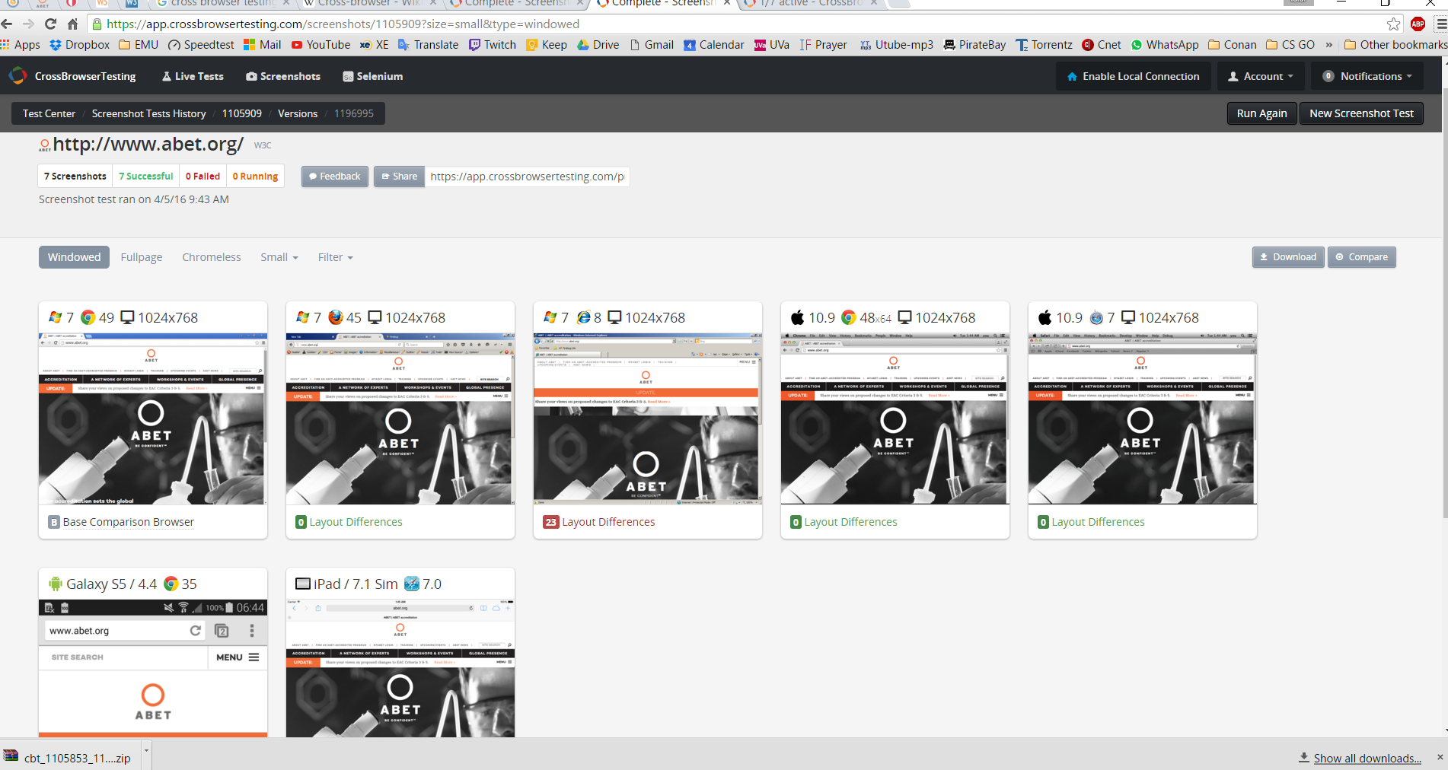

**Overall Conclusion:**

There are a lot of things to say about the quality of the three web sites and the new things we learnt by completing this project. I would like to say that the three websites are generally well designed and provide all the important functionalities that they were intended for. But looking in depth, we find that there are some differences as we saw in the above tests. It is difficult to rank the websites based on the above test as each website excels in one way or the other. There is no perfect website. We learned many new and interesting things during the completion of this project. We learned that it is sometimes important to test websites using more than one tool and more than one approach because we may discover many other stuff about the website like errors and recommendations. We also learned that it is important that the website be tested by a separate tester and not the original creator of the website because the dedicated tester’s job will be to find errors and mistakes that the original creator wouldn’t have noticed. We also learned about the importance of HTML, CSS and JavaScript in creating a website. This project made me very interested in web designing and web programming languages like HTML, CSS and JavaScript. It also made me interested in the field of testing because a website is very important to businesses in this modern world and they are the main customer attractors.

*References*

*ABET | ABET accreditation*. (2016). *Abet.org*. Retrieved 5 April 2016, from http://www.abet.org/

*Broken Link Checker*. (2016). *Smallseotools.com*. Retrieved 5 April 2016, from http://smallseotools.com/websites-broken-link-checker/

*CrossBrowserTesting App*. (2016). *crossbrowsertesting.com*. Retrieved 5 April 2016, from https://crossbrowsertesting.com/

*CSS Validator - CSS Portal*. (2016). *Cssportal.com*. Retrieved 5 April 2016, from http://www.cssportal.com/css-validator

*Eastern Mediterranean University (EMU), Cyprus*. (2016). *Eastern Mediterranean University (EMU), Cyprus*. Retrieved 5 April 2016, from http://ww1.emu.edu.tr/en/

*Free SEO Report Card: Website Grader | UpCity*. (2016). *App.upcity.com*. Retrieved 5 April 2016, from http://app.upcity.com/free-tools/seo-report-card/

*HTML Validator - HTML Portal*. (2016). *Htmlportal.net*. Retrieved 5 April 2016, from http://www.htmlportal.net/html-validator

*Is This Website Safe*. (2016). *Safeweb.norton.com*. Retrieved 5 April 2016, from https://safeweb.norton.com/

Meenan, P. (2016). *WebPagetest - Website Performance and Optimization Test*. *Webpagetest.org*. Retrieved 5 April 2016, from http://www.webpagetest.org

*METU NCC - Main Page*. (2016). *Ncc.metu.edu.tr*. Retrieved 5 April 2016, from http://ncc.metu.edu.tr/

*Nibbler - Test any website*. (2016). *Nibbler*. Retrieved 5 April 2016, from http://nibbler.silktide.com/

*Nu Html Checker*. (2016). *Validator.w3.org*. Retrieved 5 April 2016, from https://validator.w3.org/nu

*PageSpeed Insights*. (2016). *Developers.google.com*. Retrieved 5 April 2016, from https://developers.google.com/speed/pagespeed/insights/

*Responsive Design Testing*. (2016). *Mattkersley.com*. Retrieved 5 April 2016, from http://mattkersley.com/responsive/

*ScanURL.net*. (2016). *ScanURL.net*. Retrieved 5 April 2016, from http://scanurl.net/

*SEO Site Checkup*. (2016). *Seositecheckup.com*. Retrieved 5 April 2016, from http://seositecheckup.com

*Test cases for Search functionality*. (2016). *Testerdeep.wordpress.com*. Retrieved 5 April 2016, from https://testerdeep.wordpress.com/tag/test-cases-for-search-functionality/

*W3C CSS Validation Service*. (2016). *Jigsaw.w3.org*. Retrieved 5 April 2016, from http://jigsaw.w3.org/css-validator

*W3C Link Checker*. (2016). *Validator.w3.org*. Retrieved 5 April 2016, from https://validator.w3.org/checklink